# Basic troubleshooting

### Check initial connectivity

1. To verify Internal DB communication:

* Run “cat /etc/hosts” – you should get local ip to hostname resolution & DB Name/IP

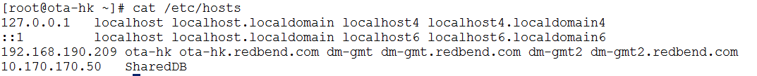

Add the record if it is not present.

* ping DB server by Hostname & IP (10.x.x.x)

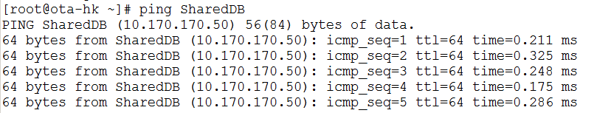

1. To verify internal communication: ping Nginx IP (192.168.x.x)

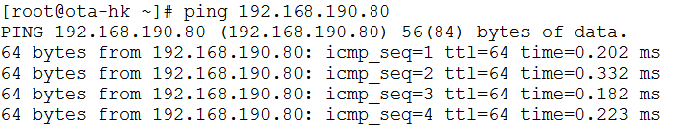

1. To verify External communication: ping Default GW (192.168.x.254)

### Check Service and ports

1. Make sure SWM is running: Run “service swm status” – you should get something similar to:

C:\Users\dora\Pictures\Support\4.PNG

1. Make sure port 8080/8443 is open: Run “lsof -i:8080” – you should get something similar to:

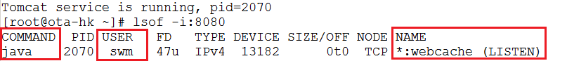

Verify COMMAND = “java”, USER = “swm“& NAME = “* :webcache (LISTEN)”

**Check FW Settings**

* Run “iptables –L” and verify 80 (http), 8080(webcache), 443(https) & 8443(pcsync-https) are open:

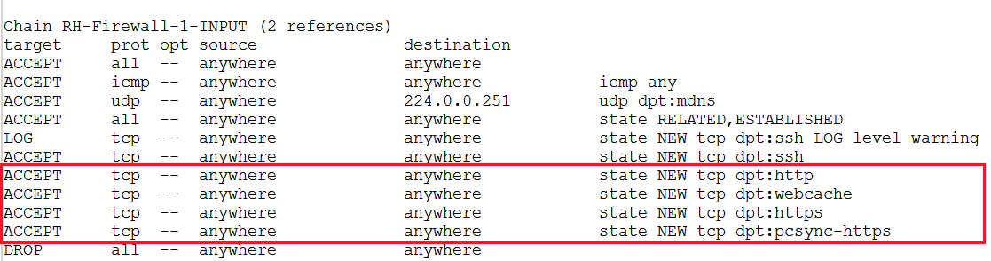

**Check ODBC connection to the DB server:**

* Run “lsof -i:1521 | grep ESTABLISHED” and verify odbc connection established - you should get multiple lines with “ESTABLISHED” status:

